Bike Rental Count Prediction

**EDWISOR**

**Submitted by: PAVAN KUMAR**

**9743391020**

**Pmithare1234@gmail.com**

**04-Feb-20**

Pavan kumar

The aim of the project is to predict the count of bike rental based on seasonal and environmental settings. By predicting the count, it would be possible to help accommodate in managing the number of bikes required on a daily basis, and being prepared for high demand of bikes during peak periods.

|  |  |  |  |  |  |  |  |  |  |  |  |  |  |  |  |  |
| --- | --- | --- | --- | --- | --- | --- | --- | --- | --- | --- | --- | --- | --- | --- | --- | --- |
|  |  |  |  |  |  |  |  | |  | |  | |  | |  | |
| Table of contents |  |  |  |  |  |  |  |  | | Page | |  | |  | |  | |
|  |  |  |  |  |  |  |  |  | |  | |  | |  | |  | |
| 1 Index |  |  |  |  |  |  |  |  | | 1-2 | |  | |  | |  | |
|  |  |  |  |  |  |  |  |  | |  | |  | |  | |  | |
| Introduction |  |  |  |  |  |  |  |  | | 3 | |  | |  | |  | |
|  |  |  |  |  |  |  |  |  | |  | |  | |  | |  | |
| 1.1 Problem Statement |  |  |  |  |  |  |  |  | | 3 | |  | |  | |  | |
|  |  |  |  |  |  |  |  |  | |  | |  | |  | |  | |
| 1.2 Data |  |  |  |  |  |  |  |  | | 4 | |  | |  | |  | |
|  |  |  |  |  |  |  |  |  | |  | |  | |  | |  | |
| 2 Methodology |  |  |  |  |  |  |  |  | | 4 | |  | |  | |  | |
|  |  |  |  |  |  |  |  |  | |  | |  | |  | |  | |
| 2.1 CRISP-DM Process |  |  |  |  |  |  |  |  | | 4 | |  | |  | |  | |
|  |  |  |  |  |  |  |  |  | |  | |  | |  | |  | |
| 2.2 Business Understanding |  |  |  |  |  |  |  |  | | 4 | |  | |  | |  | |
|  |  |  |  |  |  |  |  |  | |  | |  | |  | |  | |
| 2.3 Data Understanding |  |  |  |  |  |  |  |  | | 4-5 | |  | |  | |  | |
|  |  |  |  |  |  |  |  |  | |  | |  | |  | |  | |
| 2.4 Data Pre - Processing |  |  |  |  |  |  |  |  | | 6 | |  | |  | |  | |
|  |  |  |  |  |  |  |  |  | |  | |  | |  | |  | |
| 2.4.1 Data Exploration and Cleaning |  |  |  |  |  |  |  |  | | 6 | |  | |  | |  | |
|  |  |  |  |  |  |  |  |  | |  | |  | |  | |  | |
| 2.4.2 Missing Value Analysis |  |  |  |  |  |  |  | | 6-7 | |  | |  | |  | |
|  |  |  |  |  |  |  |  | |  | |  | |  | |  | |
| 2.4.3 Outlier Analysis |  |  |  |  |  |  |  | | 7-16 | |  | |  | |  | |
|  |  |  |  |  |  |  |  | |  | |  | |  | |  | |
| 2.4.4 Feature Engineering |  |  |  |  |  |  |  | | 16 | |  | |  | |  | |
|  |  |  |  |  |  |  |  | |  | |  | |  | |  | |
| 2.4.5 Frequency Distribution Visualization |  |  |  |  |  |  |  | | 16-38 | |  | |  | |  | |
|  |  |  |  |  |  |  |  | |  | |  | |  | |  | |
| 2.4.6 Feature Selection |  |  |  |  |  |  |  | | 39-43 | |  | |  | |  | |
|  |  |  |  |  |  |  |  | |  | |  | |  | |  | |
| 2.4.7 Feature Scaling |  |  |  |  |  |  |  | | 44-50 | |  | |  | |  | |
|  |  |  |  |  |  |  |  | |  | |  | |  | |  | |
| 2.5 Predictive Modeling |  |  |  |  |  |  |  | | 50-51 | |  | |  | |  | |
|  |  |  |  |  |  |  |  | |  | |  | |  | |  | |
| 2.5.1 Model Selection |  |  |  |  |  |  |  | | 51 | |  | |  | |  | |
|  |  |  |  |  |  |  |  | |  | |  | |  | |  | |
| 2.5.2 Multiple Linear Regression |  |  |  |  |  |  |  | | 51-57 | |  | |  | |  | |
|  |  |  |  |  |  |  |  | |  | |  | |  | |  | |
| 2.5.3 Decision Tree |  |  |  |  |  |  |  | | 58-61 | |  | |  | |  | |
|  |  |  |  |  |  |  |  | |  | |  | |  | |  | |
| 2.5.4 Random forest |  |  |  |  |  |  |  | | 61-64 | |  | |  | |  | |
|  |  |  |  |  |  |  |  | |  | |  | |  | |  | |
| Gradient Boosting |  |  |  |  |  |  |  | | 64-66 | |  | |  | |  | |
|  |  |  |  |  |  |  |  | |  | |  | |  | |  | |
| 3 Conclusion |  |  |  |  |  |  |  | | 67 | |  | |  | |  | |
|  |  |  |  |  |  |  |  | |  | |  | |  | |  | |
| 3.1 MAE, MSE, RMSE, R-squared, MAPE Model Evaluation |  |  |  |  |  |  |  | | 67 | |  | |  | |  | |
|  |  |  |  |  |  |  |  | |  | |  | |  | |  | |
| 3.2 Hyper parameter tuning |  |  |  |  |  |  |  | | 67-68 | |  | |  | |  | |
|  |  |  |  |  |  |  |  | |  | |  | |  | |  | |
| 3.3 Selected model result |  |  |  |  |  |  |  | | 68-71 | |  | |  | |  | |
|  |  |  |  |  |  |  |  | |  | |  | |  | |  | |
| 4 4.1 Brief Insights about the Cab |  |  |  |  |  |  |  | | 71-72 | |  | |  | |  | |
|  |  |  |  |  |  |  |  | |  | |  | |  | |  | |

1. Introduction

1.1 Problem Statement:

The objective of this Case is to Predication of bike rental count on daily based on the environmental and seasonal settings. In the bike rental dataset, we need to predict what could be the counting of bike rental for a given season, month and year with environmental conditions like windspeed, temperature, humidity etc., based on the historical data for the two years i.e. 2011 and 2012. Attributes: ·

1.2 Data

Understanding of data is the very first and important step in the process of finding solution of any business problem. Let’s have a quick preview of the train and test data. Will discuss in detail about the data understanding in the CRISP-DM process section.

Let’s understand shape of training and test dataset:



Preview of train data:

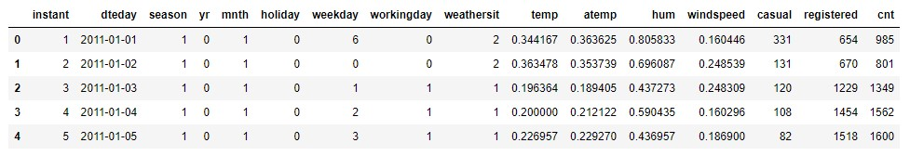

2 METHODOLOGY:

2.1 CRISP-DM Process:

CRISP-DM stands for cross-industry process for data mining. The CRISP-DM methodology provides a structured approach to planning a data mining works. The project follows CRISP DM process to develop the model for the given problem. It involves the following major steps:

1. Business understanding.

2. Data understanding.

3. Data preparation.

4. Modeling.

5. Evaluation.

6. Deployment.

2.2 Business Understanding:

Set objectives - This primary objective is what we want to accomplish from a business perspective which uncover important factors that could influence the outcome of the project that would be “How to accurately predict the Bike rental count for a particular environment condition? What are the influential factors which affects that !?”

**Produce project plan** – The plan should specify the steps to be performed during the rest of the project, including the initial selection of tools and techniques i.e., in our case the plan will be involved Understanding the available historic data and clean the data by converting into a proper shape, i.e., a data free from anomalies like missing values, outliers that can possibly produce errors; scaling the variables; applying various stat or ML models and choosing the best model for a Bike Rental Count Prediction

**Business success criteria** – Here we'll lay out the criteria that we'll use to determine whether the project has been successful from the business point of view ideally be specific and measurable. In our case the success would be related to able to accurately predict the bike rental count for a particular environment condition as input, with maximum accuracy.

2.3 Data Understanding:

We must predict bike rental count based on environmental conditions and the historical dataset of two years has dependent & independent variables, since our target variable is a continuous variable therefore this problem comes under supervised machine learning Regression problem. There are total 731 observations, 16 variables in historical data.

Data Dictionary: - The details of data attributes in the dataset are as follows let’s understand each attribute in detail.

instant: Record index

dteday: Date in yyyy-mm-dd format

season: Season (1: springer, 2: summer, 3: fall, 4: winter)

yr: Year (0: 2011, 1:2012)

mnth: Month (1 to 12) mean 1: January, 2: February…….12: December

hr: Hour (0 to 23)

holiday: weather day is holiday or not (extracted from Holiday Schedule)

weekday: Day of the week i.e., 0: Sunday, 1: Monday…….6: Saturday

workingday: If day is neither weekend nor holiday is 1, otherwise is 0.

weathersit: (extracted from Freemeteo)

1: Clear, Few clouds, Partly cloudy

2: Mist + Cloudy, Mist + Broken clouds, Mist + Few clouds, Mist

3: Light Snow, Light Rain + Thunderstorm + Scattered clouds, Light Rain + Scattered

clouds

4: Heavy Rain + Ice Pallets + Thunderstorm + Mist, Snow + Fog

temp: Normalized temperature in Celsius. The values are derived via

(t-t_min)/(t_max-t_min),

t_min=-8, t_max=+39 (only in hourly scale)

atemp: Normalized feeling temperature in Celsius. The values are derived via

(t-t_min)/(t_maxt-t_min),

t_min=-16, t_max=+50 (only in hourly scale)

hum: Normalized humidity. The values are divided to 100 (max)

windspeed: Normalized wind speed. The values are divided to 67 (max)

casual: count of casual users

registered: count of registered users

cnt: count of total rental bikes including both casual and registered

Preview of historical data for two years: 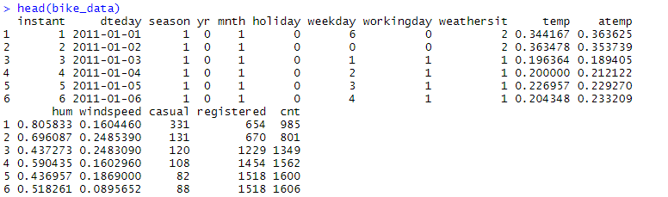

Here our response / target variable is (cnt) and predictor/independent variables are (instant), (dteday), (season), (yr), (mnth), (holiday), (workingday), (weekday), (weathersit), (temp), (atemp), (hum), (windspeed), (casual), (registered).



2.4 Data Pre - Processing:

Data preprocessing is a data mining technique that involves transforming raw data into an understandable format. Real-world data is often incomplete, inconsistent, and/or lacking in certain behaviors or trends, and is likely to contain many errors. Data preprocessing is a proven method of resolving such issues. Data preprocessing prepares raw data for further processing.

Data preprocessing is defining the quality of data and the useful information that can be derived from it directly affects the ability of our model to learn; therefore, it is extremely important that we preprocess our data before feeding it into our model. As we already know the quality of our inputs decide the quality of our output. So, once we have got our business hypothesis ready, it makes sense to spend lot of time and efforts here. Approximately, data exploration, cleaning and preparation can take up to 60-70% of our total project time. This process is often called as Exploratory Data Analysis

Listed below are data pre-processing techniques used for this Project

1) Data Exploration and Cleaning

2) Missing Value Analysis

3) Outlier analysis

4) Analyzing Distribution of each variable with respect to target variable using Visualization

5) Feature Selection

6) Feature Scaling

Let’s discuss /explain this technique in detail.

2.4.1 Data Exploration and Cleaning:

data Pre-processing is the very first step which comes with any data science project is data exploration and cleaning, according to our bike rental count prediction project below are the points which are identified in this stage:

we first imported the data into R and Python environments, explored the data by looking its dimensions, data structures, variable names, summary of data to have a glance at our data we checked first and last rows of the train dataset .renamed variables for more understanding of the data, Identified the variables for Bike Rent count prediction like what are the independent variables and target variable so our target variable is cnt (count) and predictors as mentioned below.

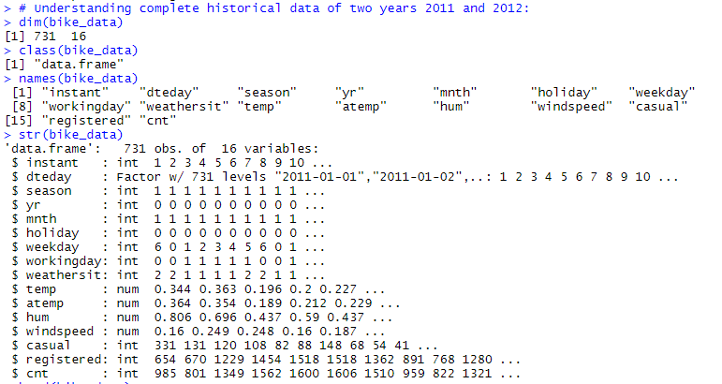



2.4.2 Missing Value Analysis

In real world missing value is the common occurrence of incomplete observations in an asset of data. Missing values can arise due to many reasons, error in uploading data unable to measure an observation etc. Due to presence of missing values in the form of 0, NA or NAN. These will affect the accuracy of model which we are building. Hence it is necessary to check for any missing values in the given data. Let’s check of the dataset for missing values and identify what type are they? In the given data there is no any missing values. So, we need not impute any missing values.

In R:



In Python:

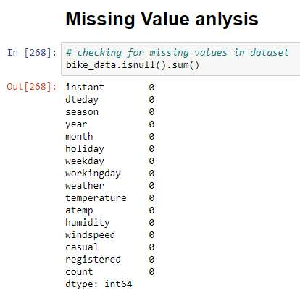

2.4.3 Outlier Analysis

An Outlier is any inconsistent or abnormal observation in a variable of dataset that deviates from the rest of the observations. These inconsistent observations can be due to manual error, poor quality/ malfunctioning equipment’s, Experimental error or correct but exceptional data based on business use case. It can cause an error in predicting the target variable/s. Hence, we need to check for the outliers and either remove the observations containing them or replace them with NA, then impute or set upper limits/lower limits or mean/median values imputation. For Outlier analysis, Boxplot to visualize and summary descriptive statistics to check range of each numeric variable and sorted the variables to detect some strange values like zeros and negative values. From below mentioned image for R & python descriptive summary statistics shows some anomalies in data which are nothing but outliers let’s discuss about each variable From the boxplot almost all the variables except “windspeed” and “humidity” does not have outliers.

In Python:

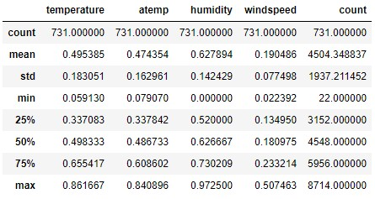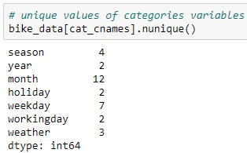

**Shape of data:**



**In R:**

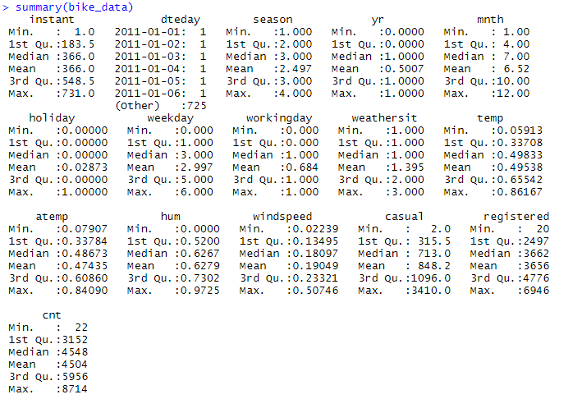

Shape of data:



In python: Box plots for both numeric and categorical variables:

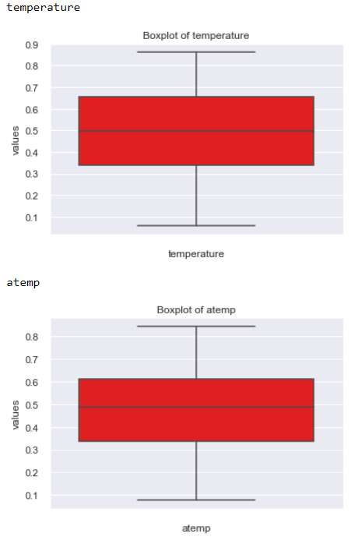

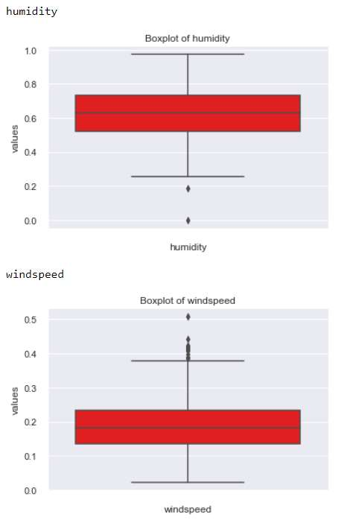

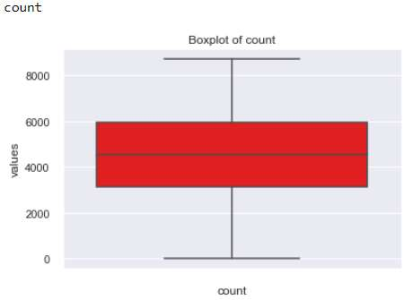

In R: Box plots for both numeric and categorical variables:

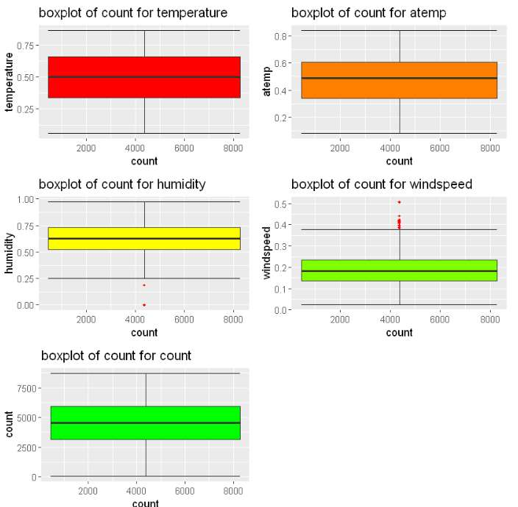

For our project we opted for capping method in which we are going to impute outlier with upper fence and lower fence value reason behind to opt this method is we don’t want to delete the observations with outliers as data collection is also a crucial step in data analytics for which client has to spend more money if don’t have any past data specially for start-up companies .by keeping this point into consideration we tried to retain the data wherever possible in the pre-processing. Boxplot stat method is one of the methods to remove outlier and we also learnt we can also treat these outliers as missing values and impute them with mean or median or knn method or delete such observations.

In R:- Box Plot after removing outliers:

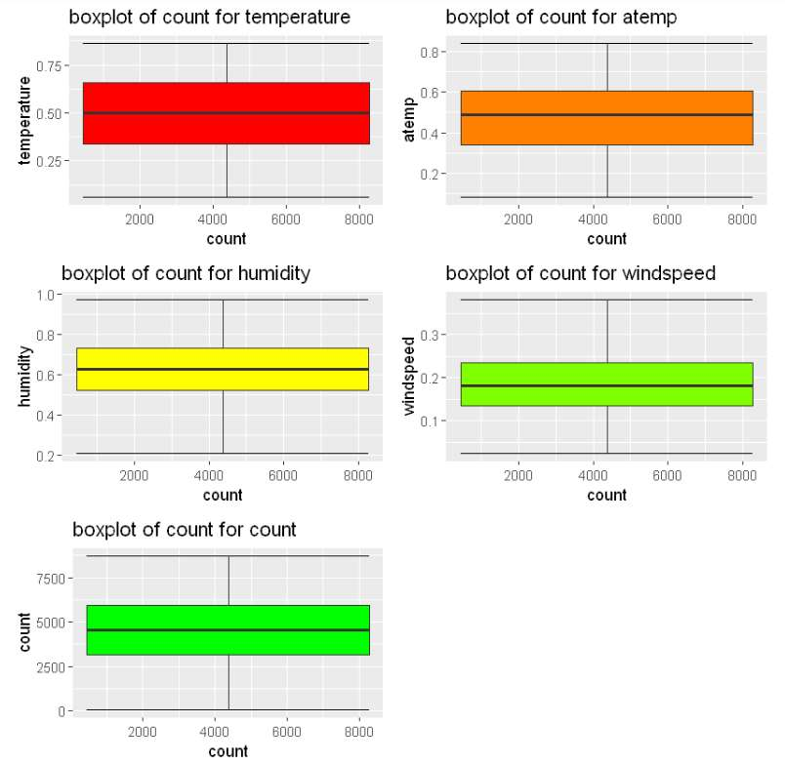

In Python:- Box Plot after removing outliers

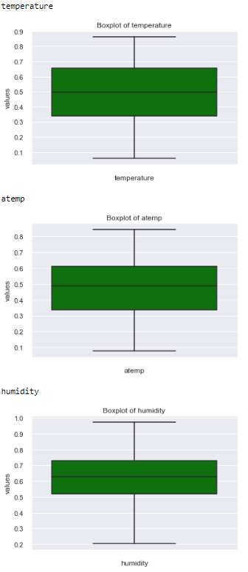

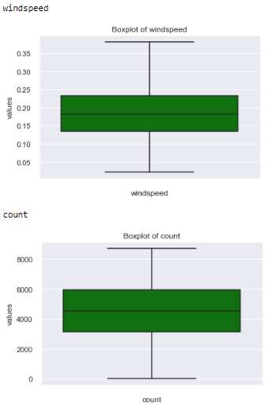

2.4.4 Feature Engineering :

Feature engineering is the science (and art) of extracting more information from existing data, not adding any new data to it, but making the data more meaningful and usable. In our Project, No need to add any new/feature variable to our data.

2.4.5 Frequency Distribution Visualization:

To check distribution of each continuous variable we plotted histogram for each variable Both in R and Python, we can also check distribution using summary or describe function. In our project it can be observed that from the below plot we can say predictor and target variables are normally distributed.

In R:

­­­­­­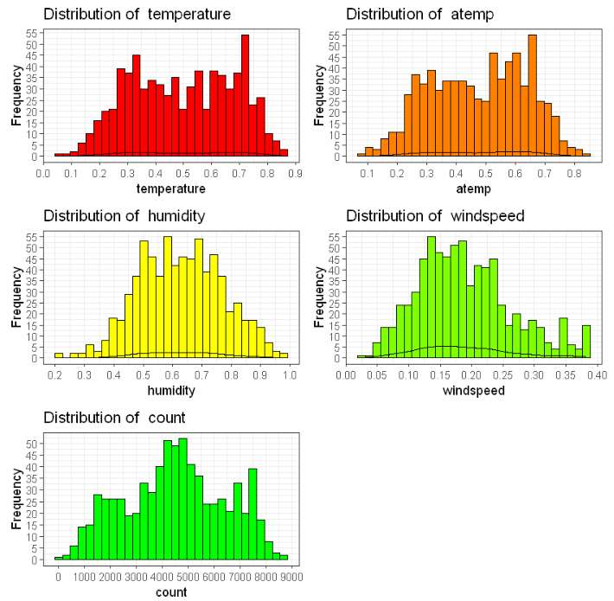

In Python:

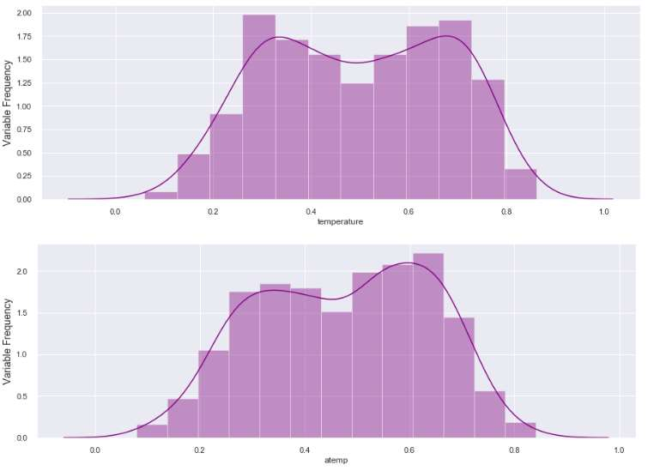



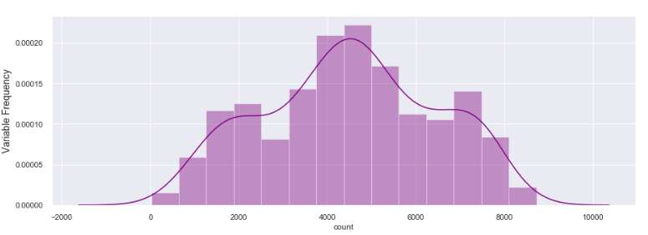

Effect of continuous variables with respect to target variable

Let’s check the impact of each continuous variables on target variable using scatterplot

In R:

Count Vs Temperature: From the below plot we can say as temperature increase

Bike rental count also increases

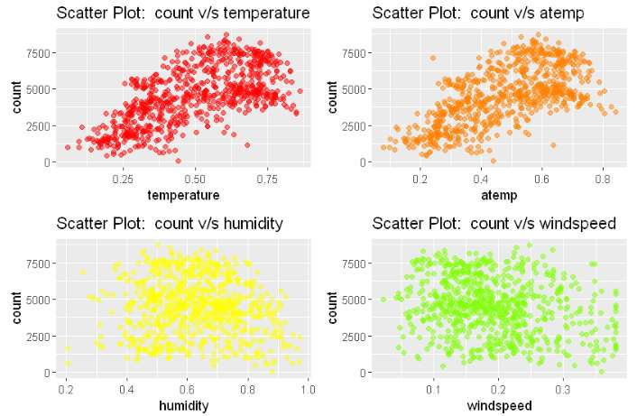

Count Vs Humidity: From the below plot we can say humidity doesn’t have any effect on bike rent count

Count Vs Windspeed: From the below plot we can say windspeed doesn’t have any effect on bike rent count

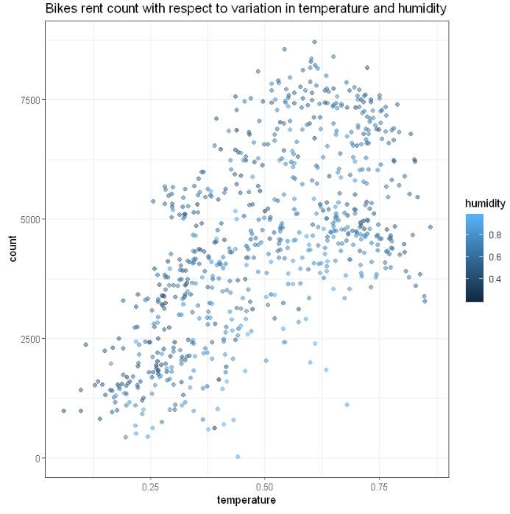

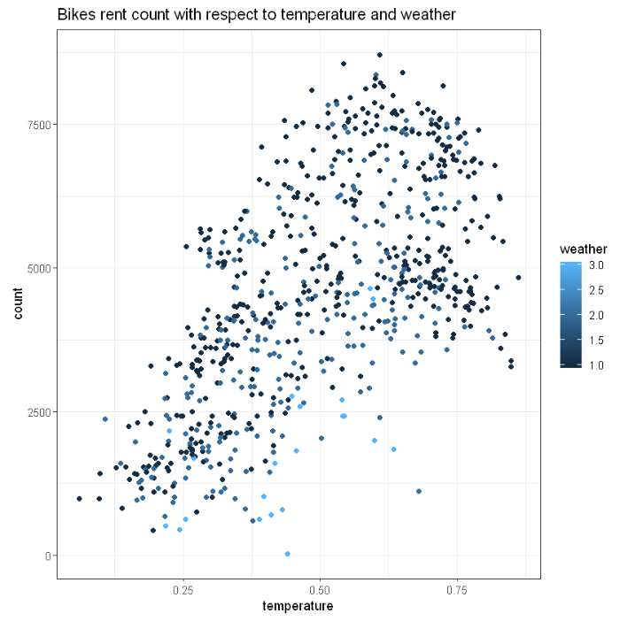

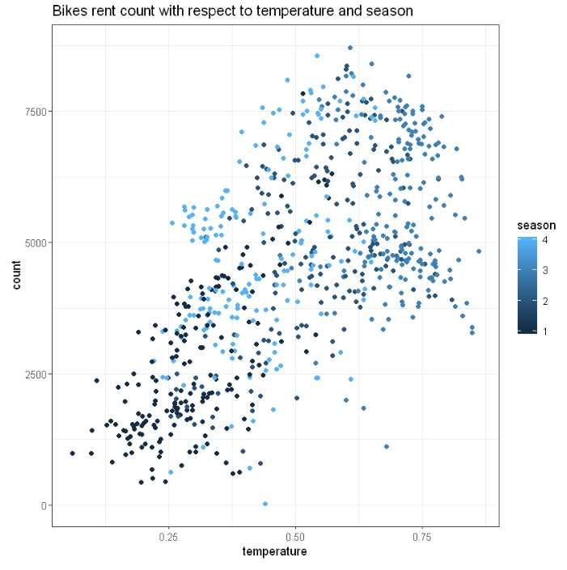

In Python:

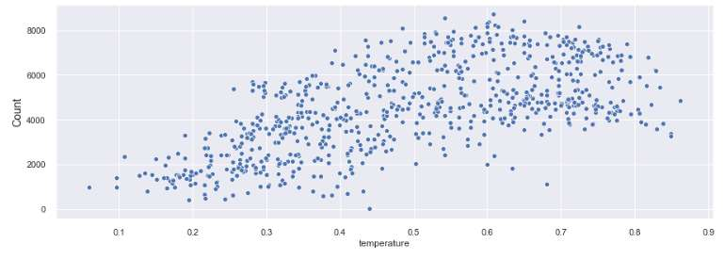

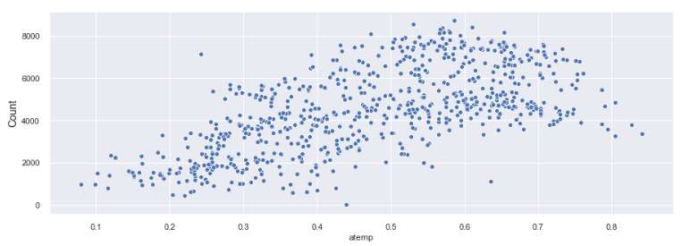

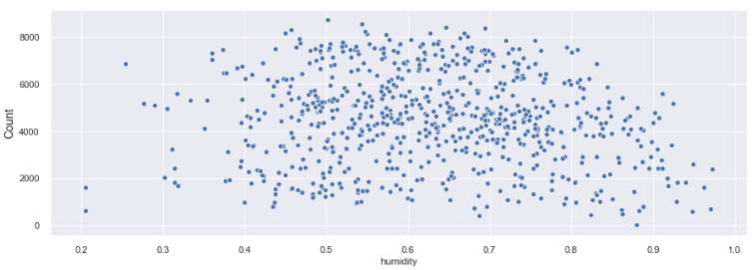

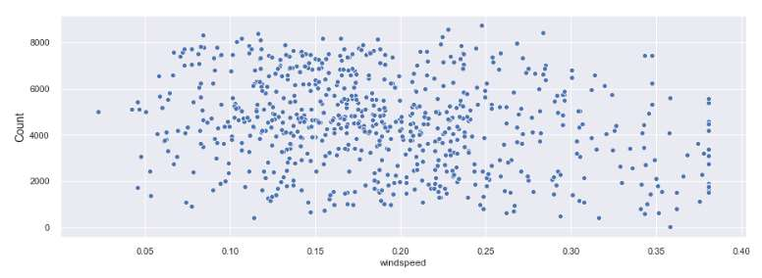

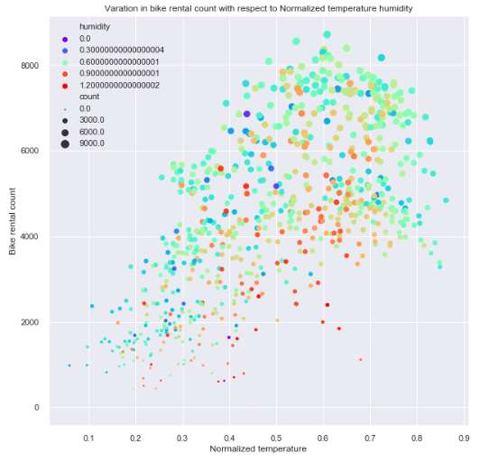

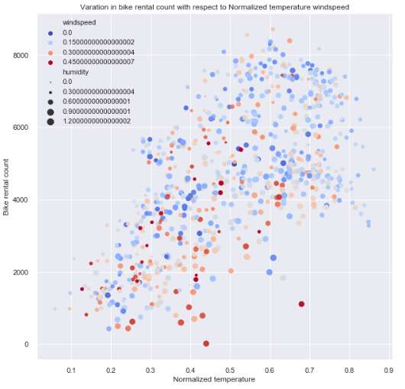

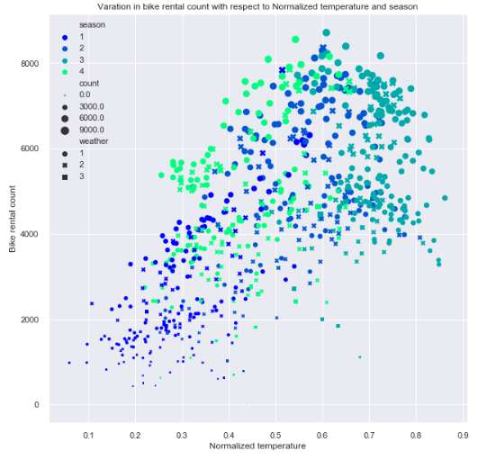

Effect of categorical variables on target variable

To check distribution of each categorical variable with respect to target variable we used bar plot and we can also look at the frequency table

Count Vs season :- Bike rent count is high in season 3(fall) and low in season1(springer)

Count Vs year :- Bike rent count is high in year 1 (in 2012)

Count Vs month :- Bike rent count is high in month of august and low in Jan

Count Vs holiday : - Bike rent count is high on holidays i.e., 0

Count Vs weekday : - From bar plot we can see maximum bikes rented on 5th day and least bikes on day 0.

Count Vs workingday : - Bike rent count is high on working day i.e., 1

Count Vs weather : - Bike rent count is high on weather 1: i.e., when the weather is Clear, Few clouds, Partly cloudy, Partly cloudy

In R:

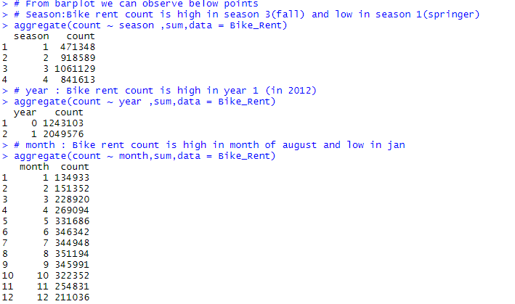

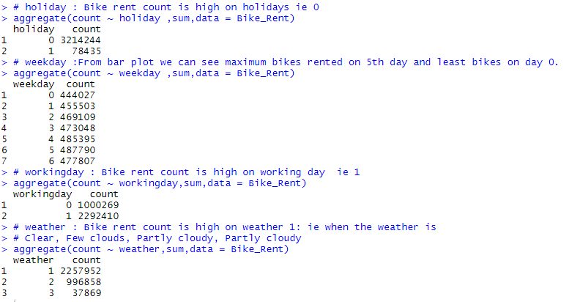

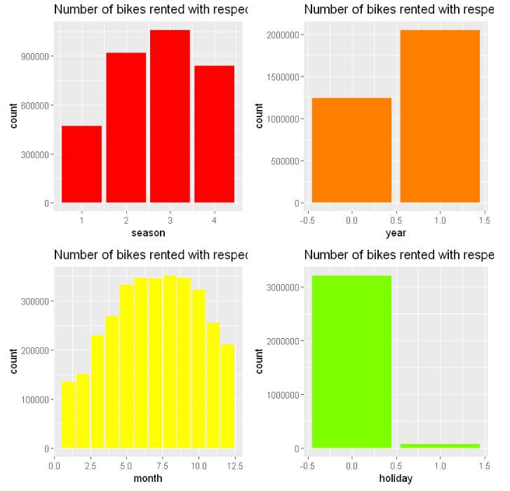

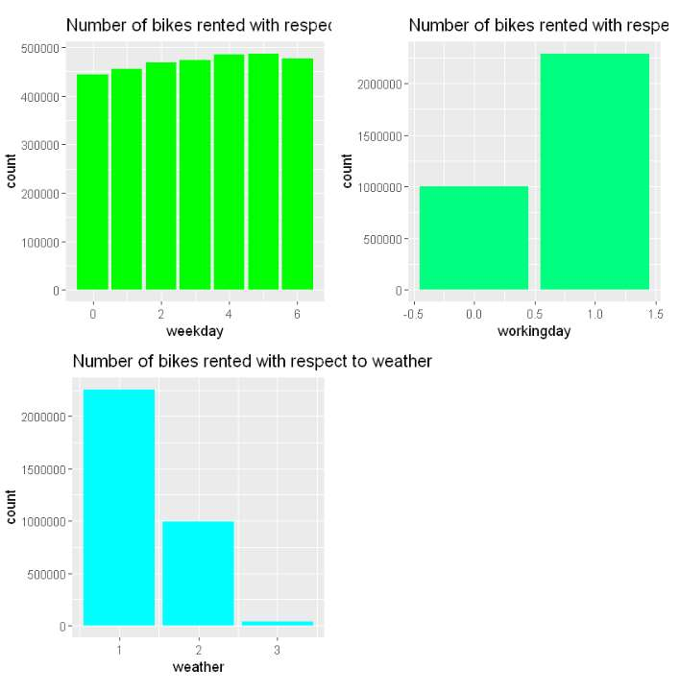

In Python:

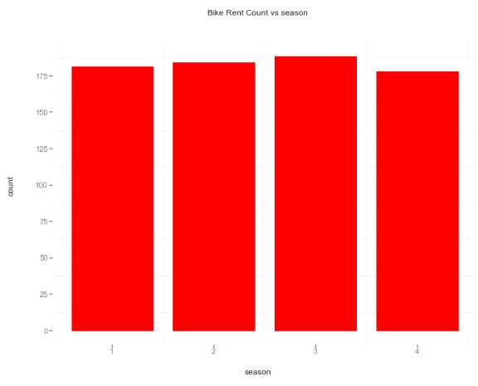

Count Vs season :- Bike rent count is high in season 3(fall) and low in season1(springer)

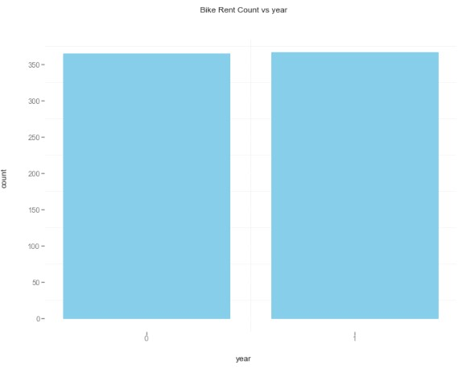

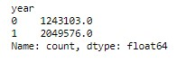

Count Vs year :- Bike rent count is high in year 1 (in 2012)

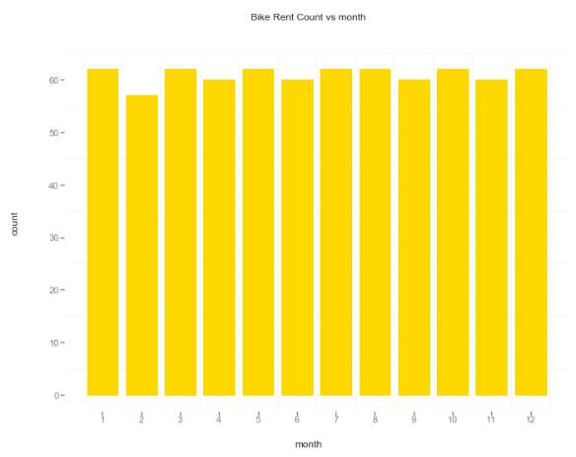

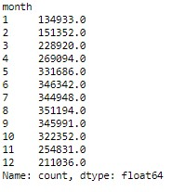

Count Vs month :- Bike rent count is high in month of august and low in Jan

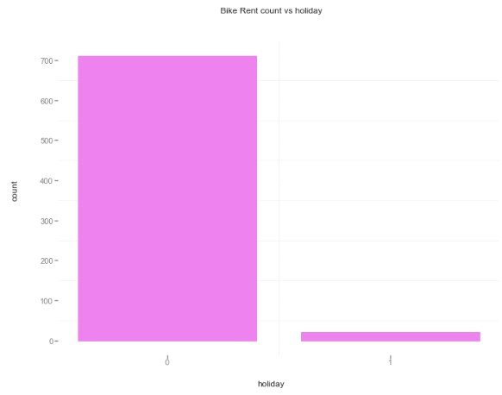

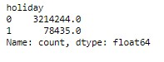

Count Vs holiday : - Bike rent count is high on holidays i.e., 0

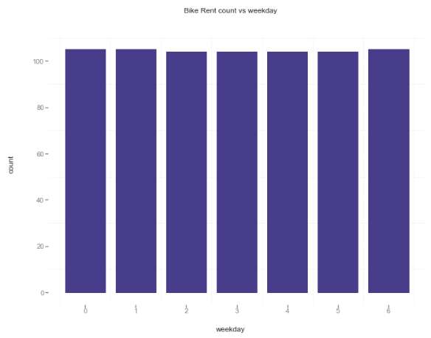

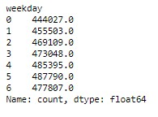

count Vs weekday : - From bar plot we can see maximum bikes rented on 5th day and least bikes on day 0

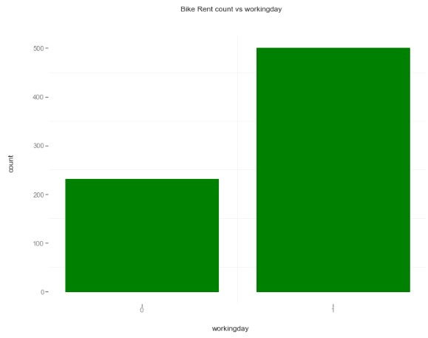

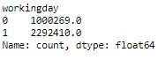

Count Vs workingday : - Bike rent count is high on working day i.e., 1

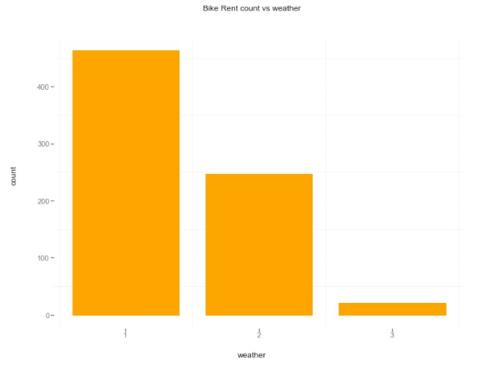

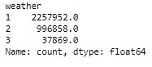

Count Vs weather : - Bike rent count is high on weather 1: i.e., when the weather is Clear, Few clouds, Partly cloudy, Partly cloudy

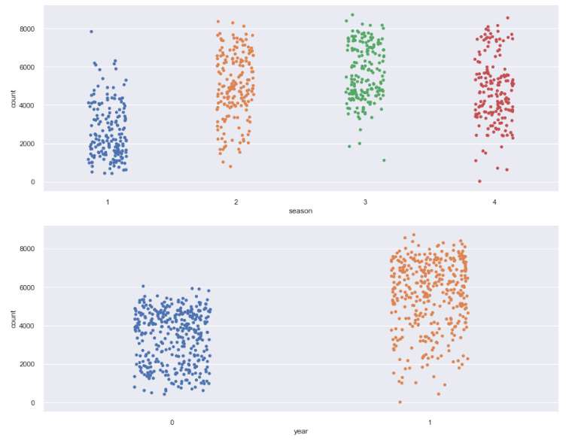

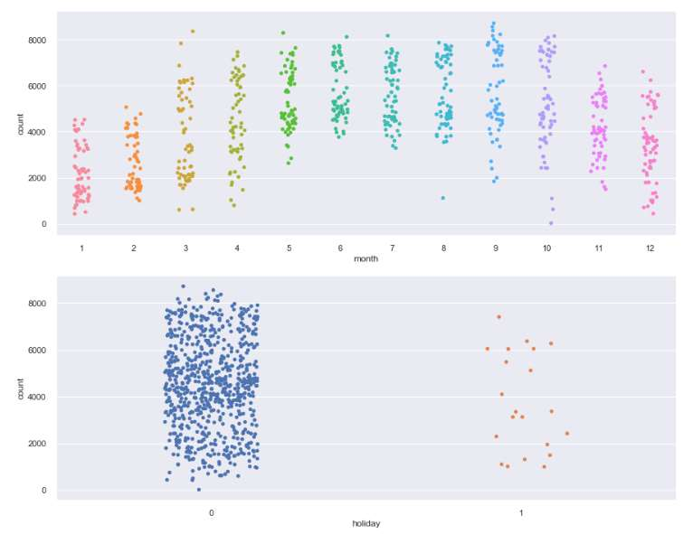

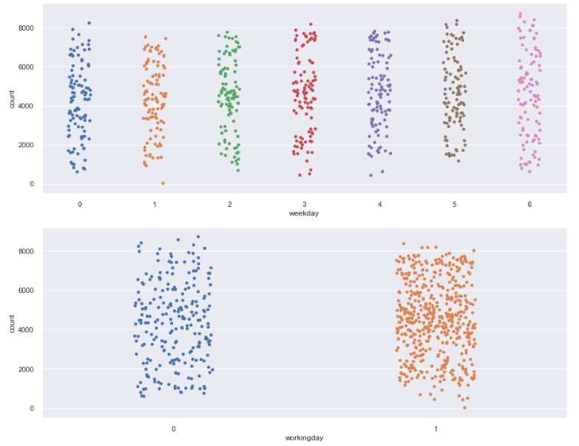

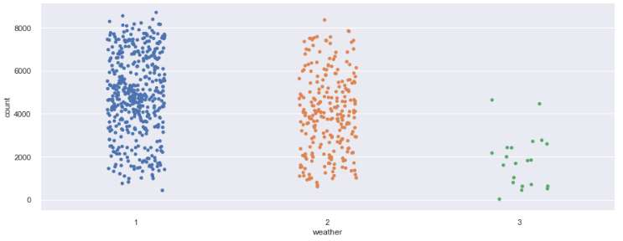

­­­

2.4.6 Feature Selection

Before creating a model, we need to assess the importance of each predictor variable in our analysis. There is a possibility that many variables in our analysis are not important at all to the problem of prediction. Hence, feature selection can help in reducing the time for computation of model as well as the complexity of the model.

Also, few models require the independent variables to be free from multicollinear effect, hence it is needed to perform various procedures to ensure that the independent variables are not collinear.

Correlation analysis includes correlation matrix and correlation plot to find out significant continuous variables and we found that there is no multi-collinearity among the predictor variables.

Using ANOVA test to find out significant categorical variable.

**In R:** Correlation matrix, Correlation Plot and ANOVA Test Results:

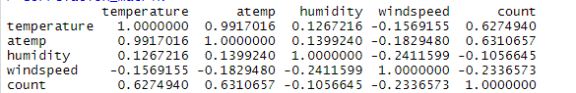

from correlation matrix and correlation plot we can say temperature variable is positively correlated with atemp variable. and rest of the variables also weekly

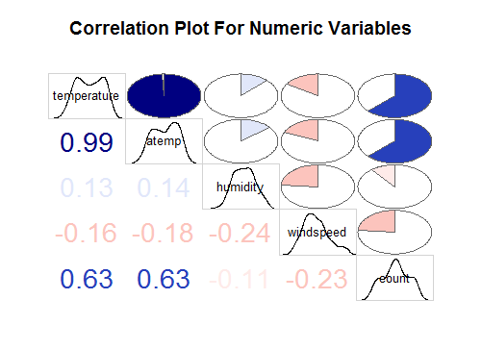

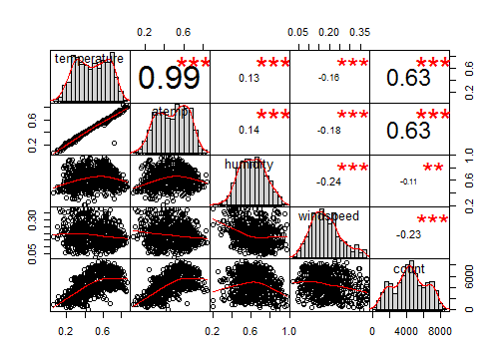

**ANOVA Test Results in R:**

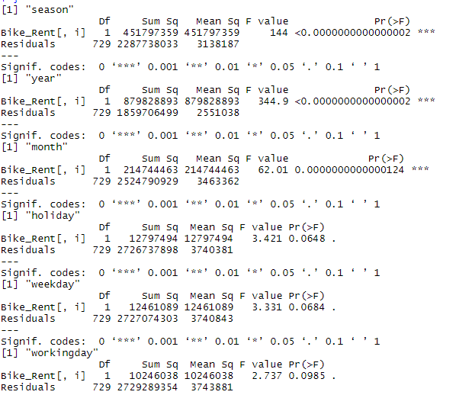

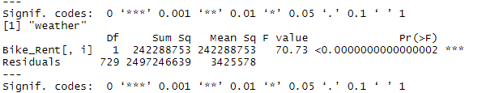

**rom the anova result, we can observe working day, weekday and holiday has p value > 0.05, so delete these variables, not to be consider in model. After Correlation and ANOVA Analysis we have remaining variables in our dataset as below**

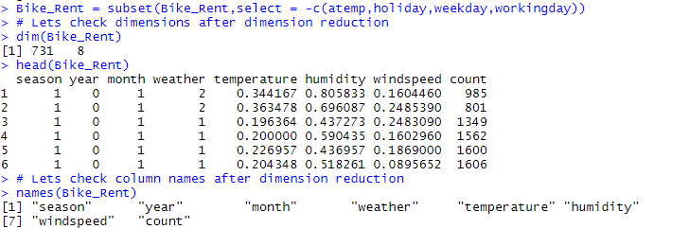

**In Python:** Correlation matrix, Correlation Plot and ANOVA Test Results:

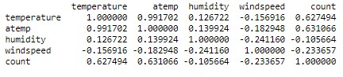

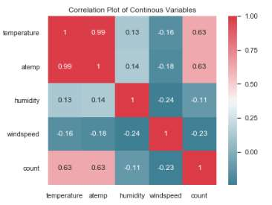

In Python: -ANOVA Test Results:

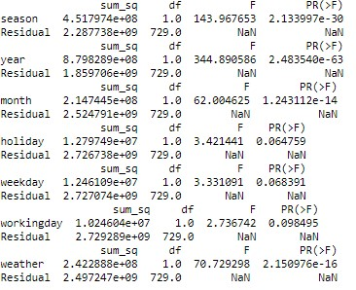

From the anova result, we can observe working day, weekday and holiday has p value > 0.05, so delete this variable not consider in model.

After Correlation and ANOVA Analysis we have remaining variables are



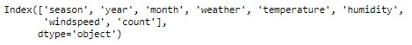

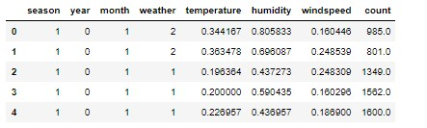

2.4.6 Feature Scaling

Feature scaling is a method used to normalize the range of independent variables or features of data. In data processing, it is also known as data normalization and is generally performed during the data preprocessing step. Since the range of values of raw data varies widely, in some machine learning algorithms, objective functions will not work properly without normalization. Widely used feature scaling methods are min max scaling and Standardization.

In the given dataset, for continuous variables data is already Normalized, so we need not to scale the data. We can check normality of data using normal QQ plot, histogram plot and summary of variables

**In R :** Let’s check the Normality of numeric variables

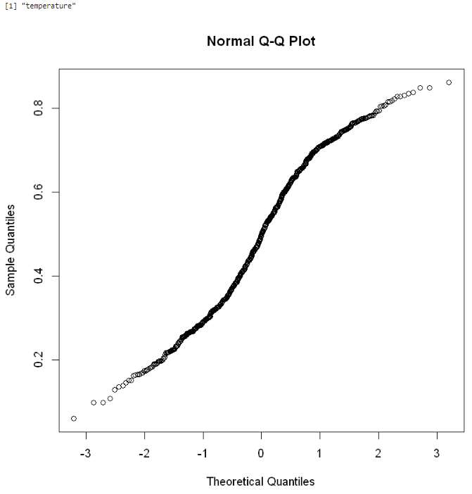

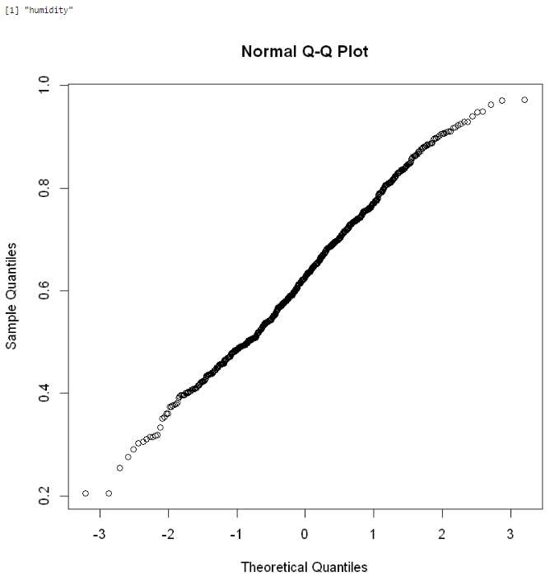

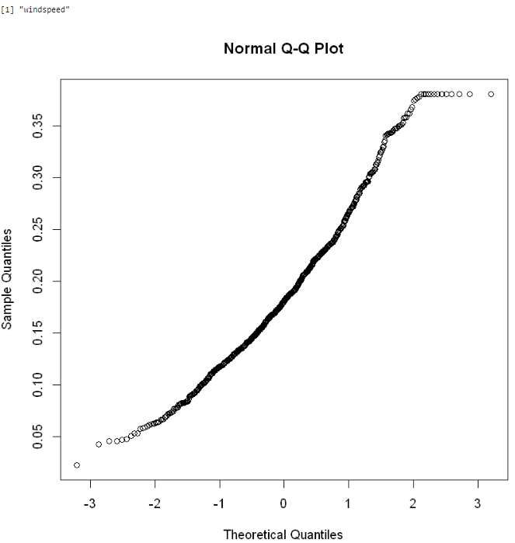

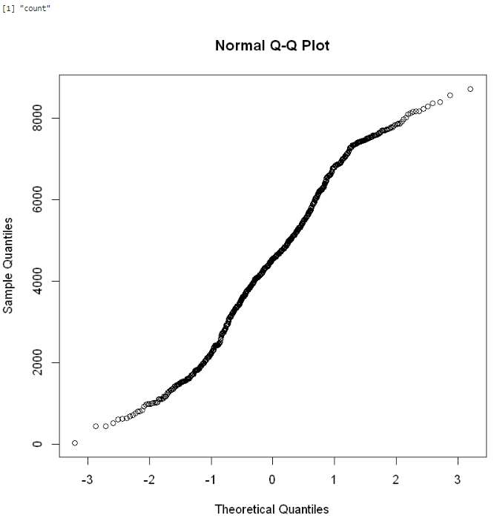

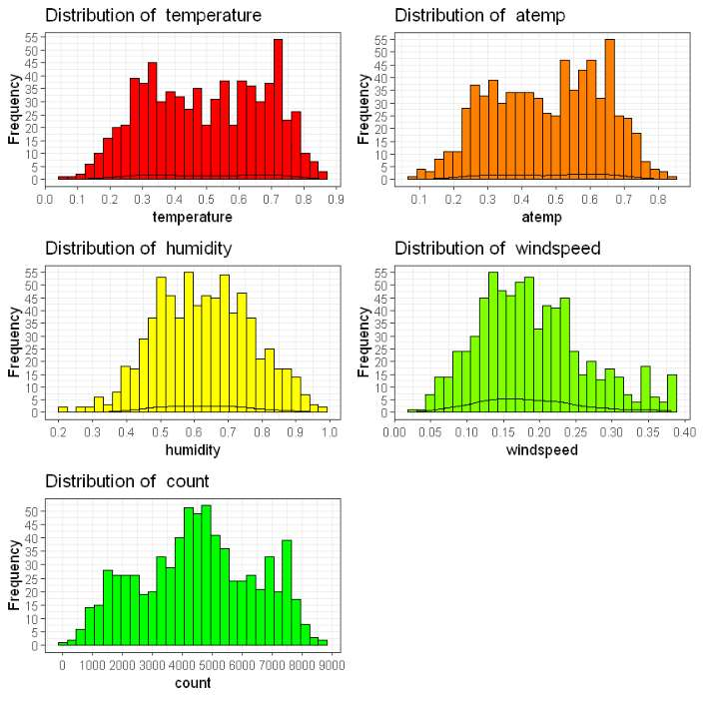

Summary of Continuous Variables:

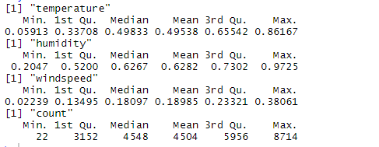

In Python : Let’s check the Normality of numeric variables

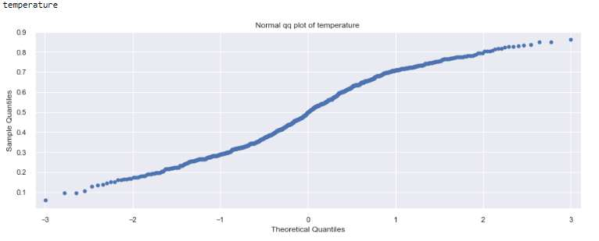

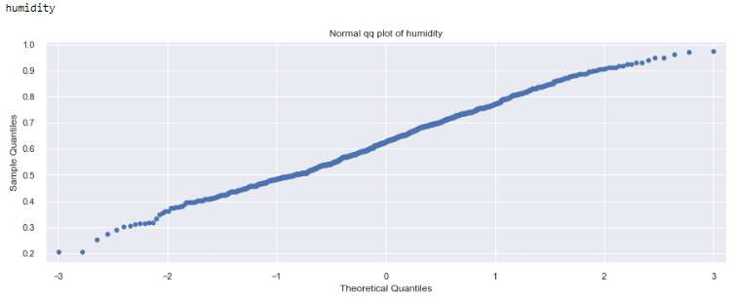

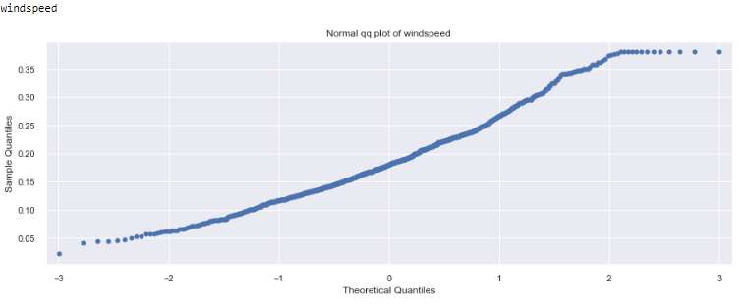

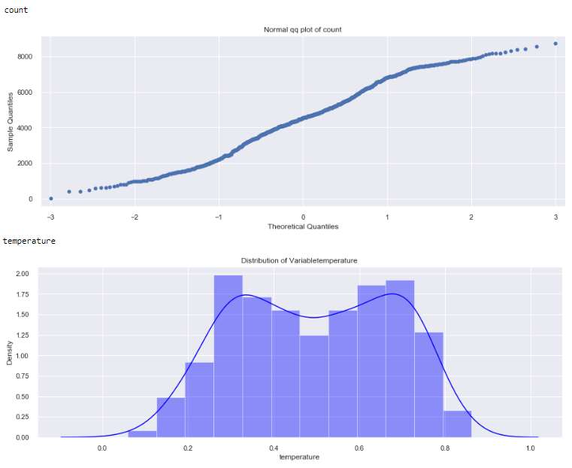

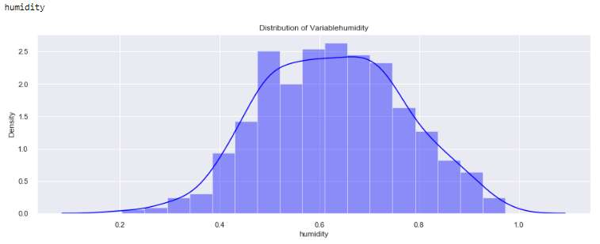

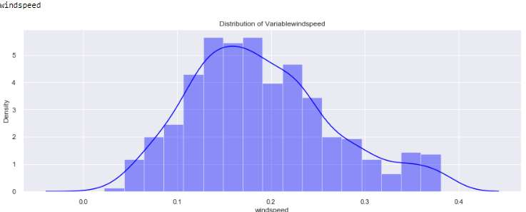

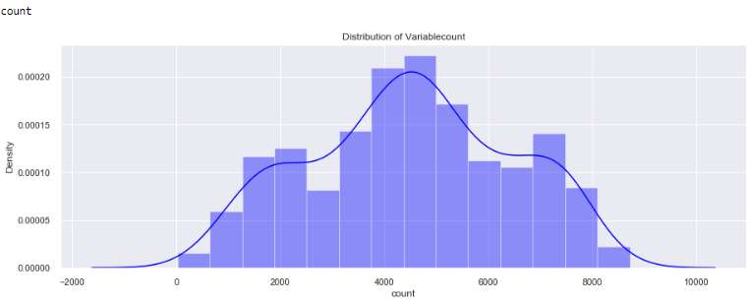

Summary of each Variable:

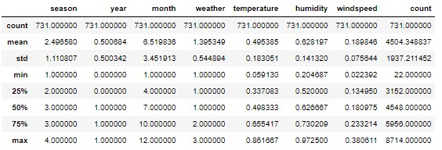

2.5 Predictive Modeling:

Predictive modeling is a commonly used statistical technique to predict future behavior. Predictive modeling solutions are a form of data-mining technology that works by analyzing historical and current data and generating a model to help predict future outcomes. It’s a technique that uses mathematical and computational methods to predict an event or outcome. A mathematical approach uses an equation-based model that describes the phenomenon under consideration. The model is used to forecast an outcome at some future state or time based upon changes to the model inputs. The model parameters help explain how model inputs influence the outcome.

Predictive modeling is a process that uses data mining and probability to forecast outcomes. Each model is made up of a number of predictors, which are variables that are likely to influence future results. Once data has been collected for relevant predictors, a statistical model is formulated. The model may employ a simple linear equation, or it may be a complex neural network, mapped out by sophisticated software. As additional data becomes available, the statistical analysis model is validated or revised.

2.5.1 Model Selection

It is the task of selecting a statistical model from a set of candidate models, given data. In the simplest cases, a pre-existing set of data is considered. However, the task can also involve the design of experiments such that the data collected is well-suited to the problem of model selection.

Once completing data cleaned next process is model selection it is based on problem statement. In bike rental count prediction problem statement understood that it comes under supervised machine learning because it has both input and output variables and its regression problem as out target variable is count which is of numeric / continuous type. So, we can consider linear regression, Decision Tree, Random Forest etc., In our project used linear regression, Decision Tree, Random Forest and Gradient Boosting models.

Error matrix chosen for the given problem statement is Root Mean Squared Error (RMSE) and R2(R-Squared). Before building an any model we divided the preprocessed Bike_Rent data set in to train and test set. Data was divided into 80:20 ratio, 80% of data was used as ‘train’ set and rest of the 20% was used as ‘test’ set. The training set is used to fit the model and the test set is used to estimate the model prediction accuracy.

2.5.2 Multiple Linear Regression

Multiple linear regression (MLR), also known simply as multiple regression, is a statistical technique that uses several explanatory variables to predict the outcome of a response variable. The goal of multiple linear regression (MLR) is to model the linear relationship between the explanatory (independent) variables and response (dependent) variable. In essence, multiple regression is the extension of ordinary least-squares (OLS) regression that involves more than one explanatory variable.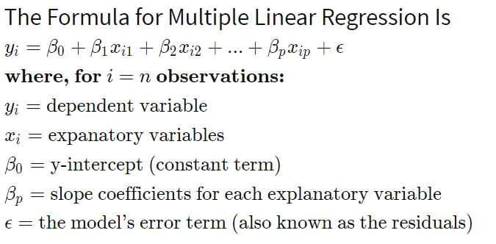

Explaining Multiple Linear Regression

A simple linear regression is a function that allows an analyst or statistician to make predictions about one variable based on the information that is known about another variable. Linear regression can only be used when one has two continuous variables— an independent variable and a dependent variable. The independent variable is the parameter that is used to calculate the dependent variable or outcome. A multiple regression model extends to several explanatory variables.

The multiple regression model is based on the following assumptions:

* There is a linear relationship between the dependent variables and the independent variables.
* The independent variables are not too highly correlated with each other.
* Yi observations are selected independently and randomly from the population.
* Residuals should be normally distributed with a mean of 0 and variance σ.

The coefficient of determination (R-squared) is a statistical metric that is used to measure how much of the variation in outcome can be explained by the variation in the independent variables. R2 always increases as more predictors are added to the MLR model even though the predictors may not be related to the outcome variable. R2 by itself can't thus be used to identify which predictors should be included in a model and which should be excluded. R2 can only be between 0 and 1, where 0 indicates that the outcome cannot be predicted by any of the independent variables and 1 indicates that the outcome can be predicted without error from the independent variables.

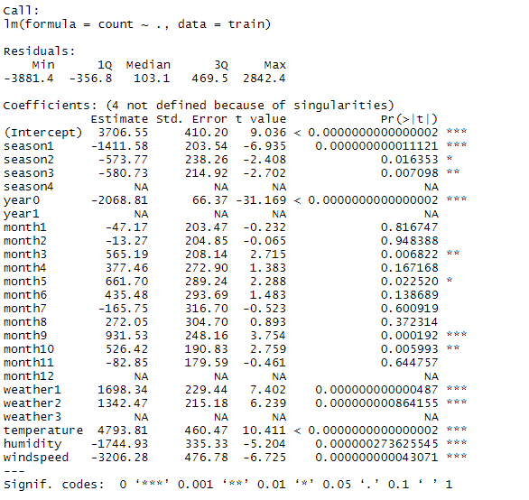

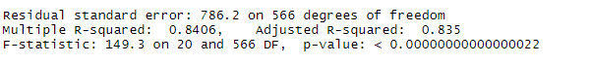

Let’s check the assumptions of linear regression:

a) Error should follow normal distribution

b) Error should follow Homoscadacity or No Heteroscadacity

c) No multicollinearity among the independent variables

d) No serial / autocorrelation in error

Error should follow normal distribution:

To check this assumption, we plot normal QQ plot. The normal QQ plot helps us to determine if our target variable is normally distributed by plotting quantiles (i.e. percentiles) from our distribution against a theoretical distribution. If our data is normally distributed, it will be plotted in a generally straight line on the QQ plot. We can also plot histogram where error should show a curvy bell shape for our project this assumption satisfied.

Error should follow Homoscadacity or No Heteroscadacity :

To check this assumption, we can use residual plot Residual plots help us evaluate and improve our regression model. A residual is the difference between the observed value of the dependent variable (y) and the predicted value (ŷ). A “good” residual vs. fitted plot should be relatively shapeless without clear patterns in the data, no obvious outliers, and be generally symmetrically distributed. For our Project this assumption is violated (residuals following a pattern not scattered) we can see it in Residuals vs fitted plot.

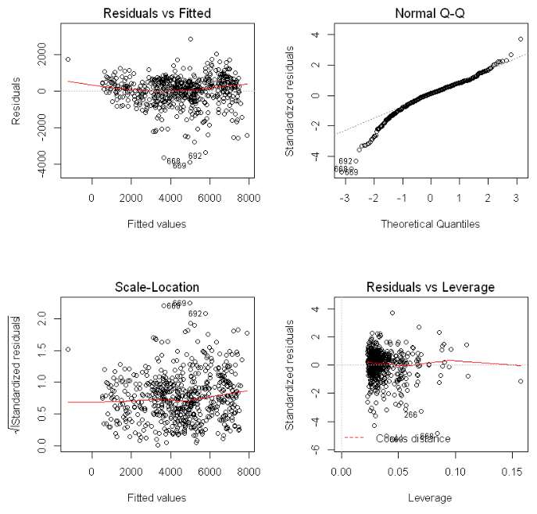

No multicollinearity among the independent variables

To check this assumption, we are going to use Variance Inflation Factor (VIF) Variance inflation factor is a measure of the amount of multicollinearity in a set of multiple regression variables The Variance Inflation Factor (VIF) is 1/Tolerance, it is always greater than or equal to 1. There is no formal VIF value for determining presence of multicollinearity. Values of VIF that exceeds 10 are often regarded as indicating multicollinearity, but in weaker models values above 2.5 may be a cause for concern for our project VIF values are within the range and this assumption is satisfied.

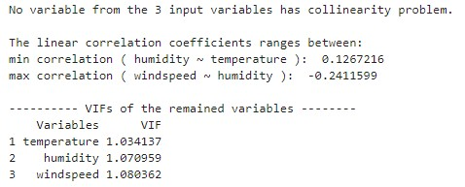

No serial / autocorrelation in error:

Errors of all observation independent each other we can check this assumption using dwt test or Durbin Watson test The Durbin Watson (DW) statistic is a test for autocorrelation in the residuals from a statistical regression analysis. The Durbin Watson statistic will always have a value between 0 and 4. Avalue of 2.0 means that there is no autocorrelation detected in the sample. Values from 0 to less than 2 indicate positive autocorrelation and values from 2 to 4 indicate negative autocorrelation. So, our model is fine with this assumption.

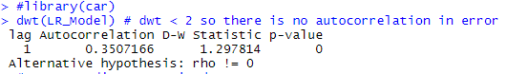

Using linear regression for our project we have got MAPE value about 19.48% which says our model is only 80.5% accurate. In python 83.79% accurate. it means linear regression is not performing well on our dataset. Lets check other Algorithms.

In R:

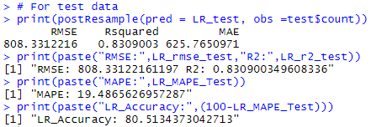

In Python:

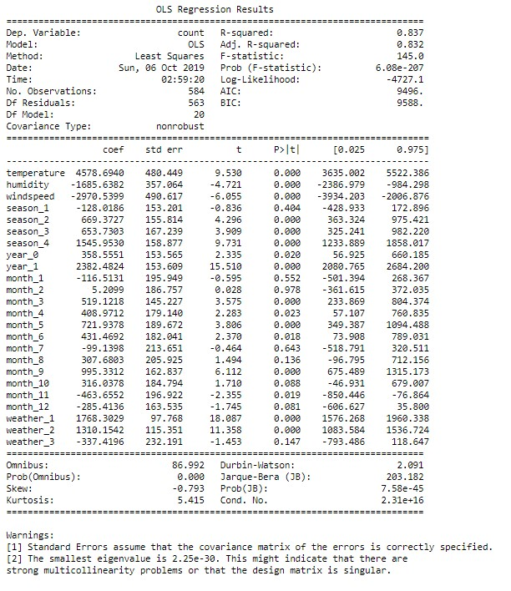

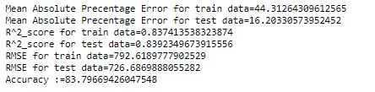

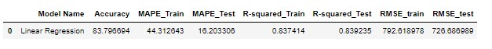

2.5.3 Decision Tree

Decision Tree is a supervised machine learning algorithm, which is used to predict the data for classification and regression. It accepts both continuous and categorical variables. A decision tree is a decision support tool that uses a tree like graph or model of decisions and their possible consequences, including chance event outcomes, resource costs, and utility. Each branch connects nodes with “and” and multiple branches are connected by “or”. Extremely easy to understand by the business users. It provides its output in the form of rule, which can easily understand by a non –technical person also. Output of Decision tree regression model is as below

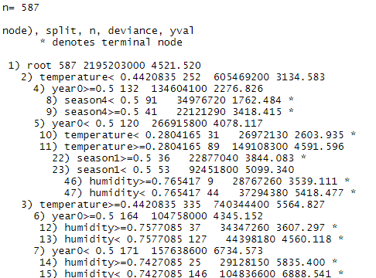

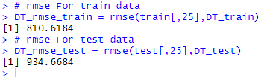

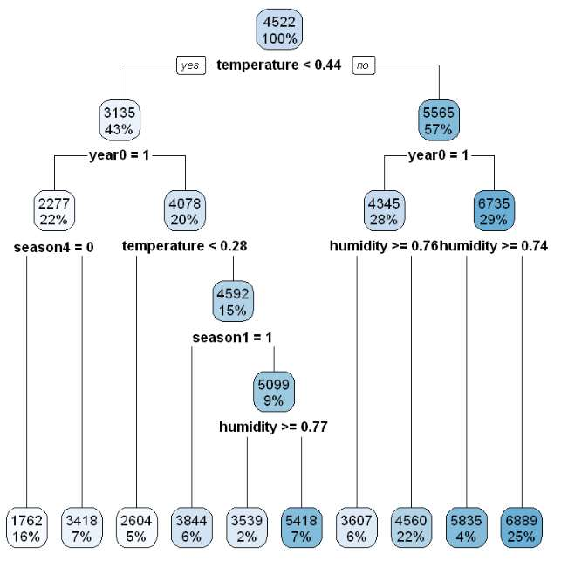

Using Decision tree to predict fare amount we got MAPE value is around 24.57% which means our model is 75.42% accurate . In python 73.29% accurate. Lets Cross validate.

**In R:**

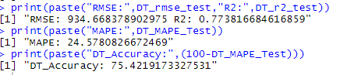

**In Python:**

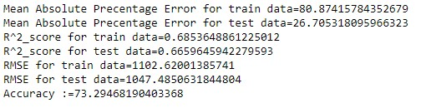



(A) Random Search CV in Decision Tree

In R:

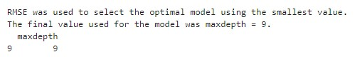

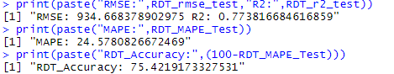

In Python:

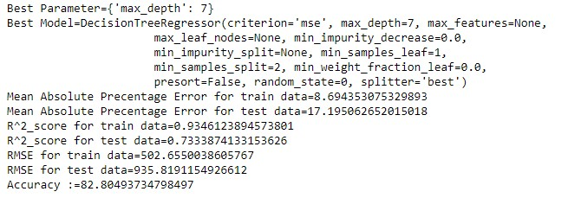



(B) Grid Search CV in Decision Tree

In R:

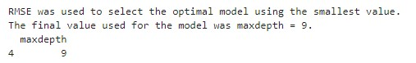

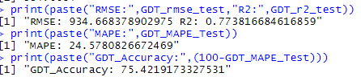

In Python:

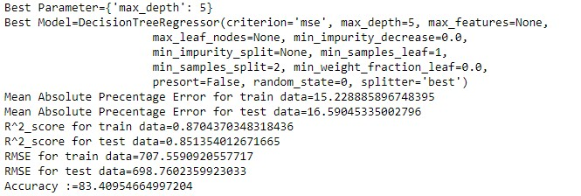

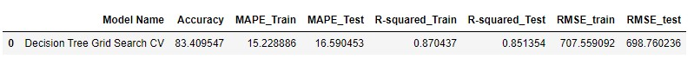

2.2.4 Random forest

Random Forest is an ensemble technique that consists of many decision trees. The idea behind Random Forest is to build N number of trees to have more accuracy in dataset. It is called random forest as we are building n no. of trees randomly. In other words, to build the decision trees it selects randomly N no of variables and n no of observations.

It means to build each decision tree on random forest we are not going to use the same data. The higher no of trees in the random forest will give higher no of accuracy, so in random forest we can go for multiple trees. It can handle large no of independent variables without variable deletion and it will give the estimates that what variables are important. The Number of trees used in R and Python for random forest model are 200 no’s

Using Random Forest model, MAPE value is around 16.73% which means our model is 83.26% accurate in R and 87.12%in Python. Lets Cross validate the same.

**In R:**

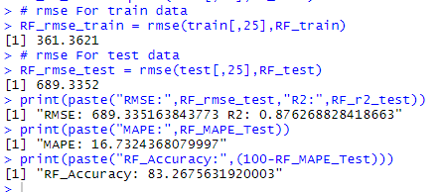

In Python:

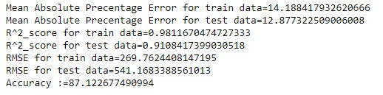

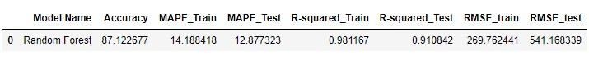

(A) Random Search CV in Random Forest

In R:

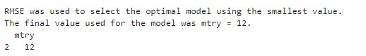

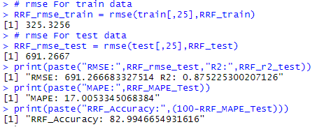

In Python:

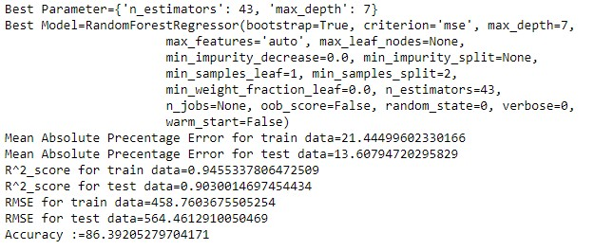



(B) Grid Search CV in Random Forest

In R:

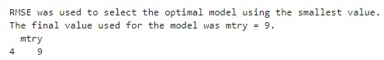

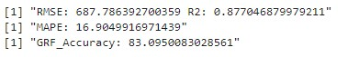

In Python:

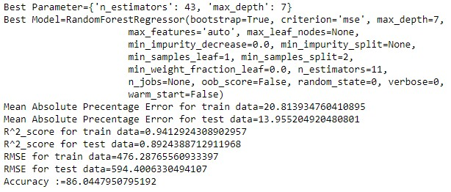



2.5.5 Gradient Boosting

Gradient boosting is a machine learning technique for regression and classification problems, It produces a prediction model in the form of an ensemble of weak learner models and produce a strong learner with less misclassification and higher accuracy. It feed the error from one decision tree to another decision tree and generates a strong classifier or Regressor

Using Gradient Boosting model, MAPE value is around 16.81% which means our model is 83.18% accurate in R and 87.26%in Python. Lets Cross validate the same.

In R:

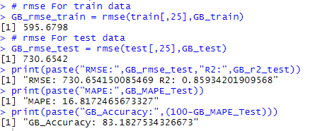

In Python:

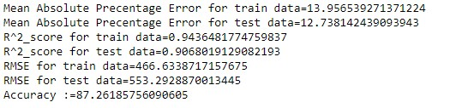  


(A) Random Search CV in Gradient Boosting

In R:

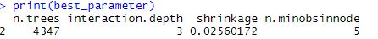

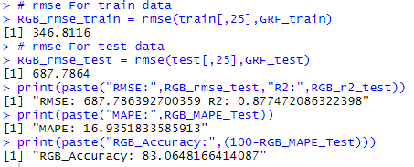

In Python:

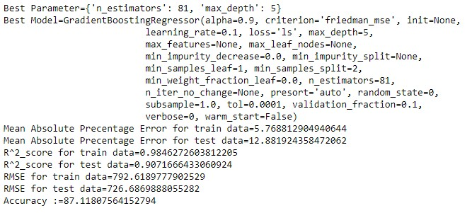



(B) Grid Search CV in Gradient Boosting

In R:

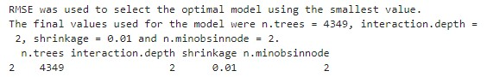

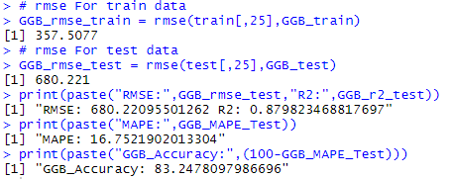

In Python:

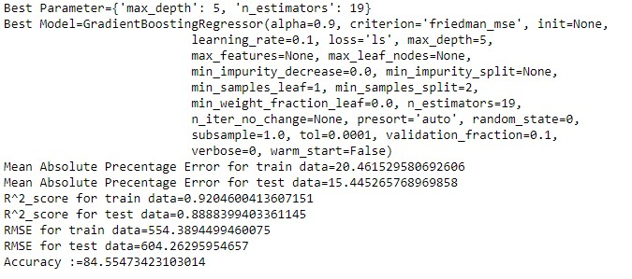



3.1 Conclusion:

3.2 MAE, MSE, RMSE, R-squared, MAPE

We have calculated RMSE, R-Square, MAE (Mean Absolute Error) for all the three models. Root Mean Square Error (RMSE) is the standard deviation of the residuals (prediction errors) Residuals are a measure of how far from the regression line data points are, RMSE is a measure of how spread out these residuals are. In other words, it tells you how concentrated the data is around the line of best fit. Whereas R squared is a relative measure of fit, RMSE is an absolute measure of fit. As the square root of a variance, RMSE can be interpreted as the standard deviation of the unexplained variance and has the useful property of being in the same units as the response variable. Lower values of RMSE indicate better fit. R- squared is basically explains the degree to which input variable explain the variation of the output. In simple words R-Squared tells how much variance of dependent variable explained by the independent variable. It is a measure if goodness of fit in regression line. We also said about MAPE value for all the three models which is a measure of prediction accuracy of a forecasting method. It measures accuracy in terms of percentage.

3.2 Hyper parameter tuning:

In statistics, hyperparameter is a parameter from a prior distribution; it captures the prior belief before data is observed. In any machine learning algorithm, these parameters need to be initialized before training a model. Choosing appropriate hyperparameters plays a crucial role in the success of good model. Since it makes a huge impact on the learned model. For example, if the learning rate is too low, the model will miss the important patterns in the data. If it is high, it may have collisions.

We used two techniques of Hyperparameter for our models :

* Random Search
* Grid Search

Random Search :

Random search is a technique where random combinations of the hyperparameters are used to find the best solution for the built model. In this search pattern, random combinations of parameters are considered in every iteration. The chances of finding the optimal parameter are comparatively higher in random search because of the random search pattern where the model might end up being trained on the optimized parameters without any aliasing.

Grid Search :

Grid search is a technique which tends to find the right set of hyper parameters for the particular model. Hyper parameters are not the model parameters and it is not possible to find the best set from the training data. Model parameters are learned during training when we optimize a loss function using something like a gradient descent. In this tuning technique, we simply build a model for every combination of various hyper parameters and evaluate each model. The model which gives the highest accuracy wins. The pattern followed here is similar to the grid, where all the values are placed in the form of a matrix. Each set of parameters is taken into consideration and the accuracy is noted. Once all the combinations are evaluated, the model with the set of parameters which give the top accuracy is considered to be the best. We used these two techniques for Decision tree, Random Forest, Gradient boosting models.

3.3 Selected Model Results:

Predicted Bike Rental count using Random Forest Model (83.26%)

in R.

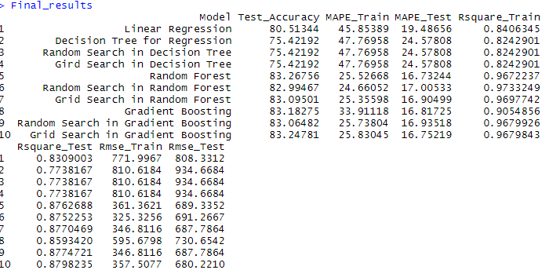

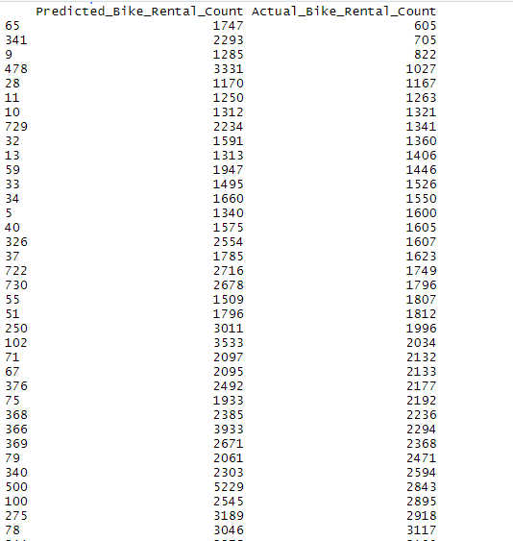

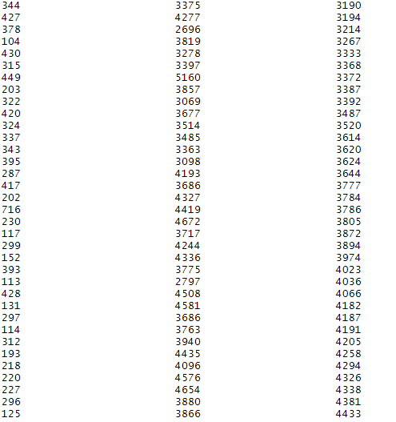

In Python:

Predicted Bike Rental count using Gradient Boosting Model (87.26%) in Python

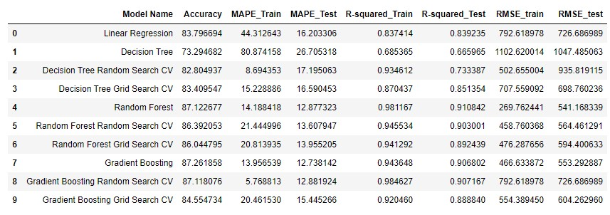

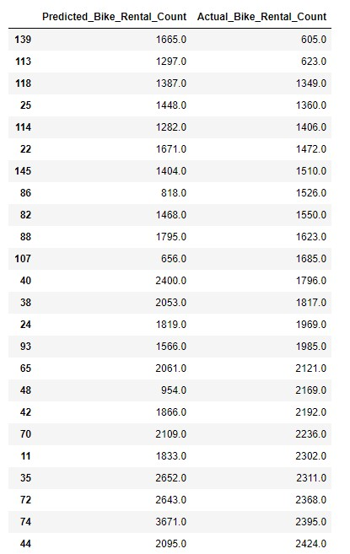

4.1 Brief Insights about the Bike Rental Count prediction Project

From this bike rental count project, we analyzed and found below observations.

1) Temperature variable has major impact on bike rental count

2) In season 3 (Sept, Oct, Nov) there will be more bike rental counts

3) When the weather is 1 means when weather is Clear, Few clouds, Partly cloudy then there will be more bike rental counts

4) In the month of August bike rental count will be very high

5) Windspeed and humidity don’t have any impact on bike rental count and these two Variables are negatively correlated with all variables

6) On Friday or fifth day of week bike rental count is more

7) Even during working days bike rental count is more